GUIDELINE NO. 11
Exterior Painting
https://www.sherwin-williams.com/homeowners/color/find-and-explore-colors/hoa/hoschton/ga/reunion-country-club/

If you are planning to refresh your house color while maintaining the existing color scheme, it is still necessary to fill out a modification form. This form must be submitted to John Albano ( JohnAlbano@fieldstonerp.com ) for review and approval.

Photograph your home and homes on either side (in most cases, adjacent homes cannot be painted the same colors). Adjacent homes will be considered the homes on either side and the three homes across the street. (See Examples below.)

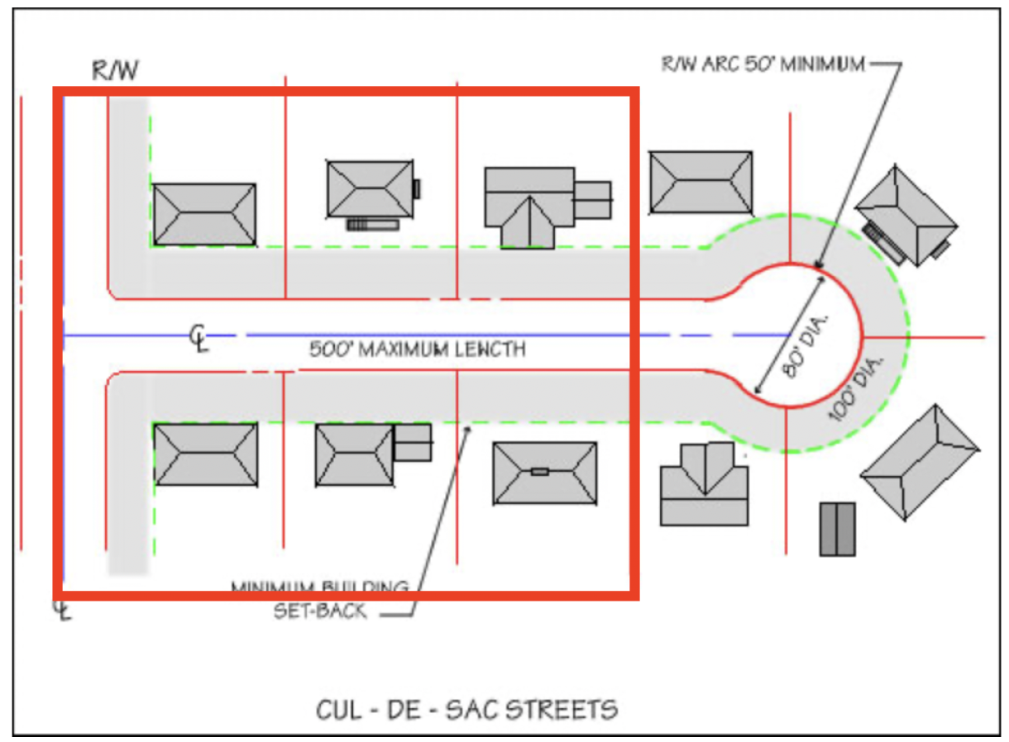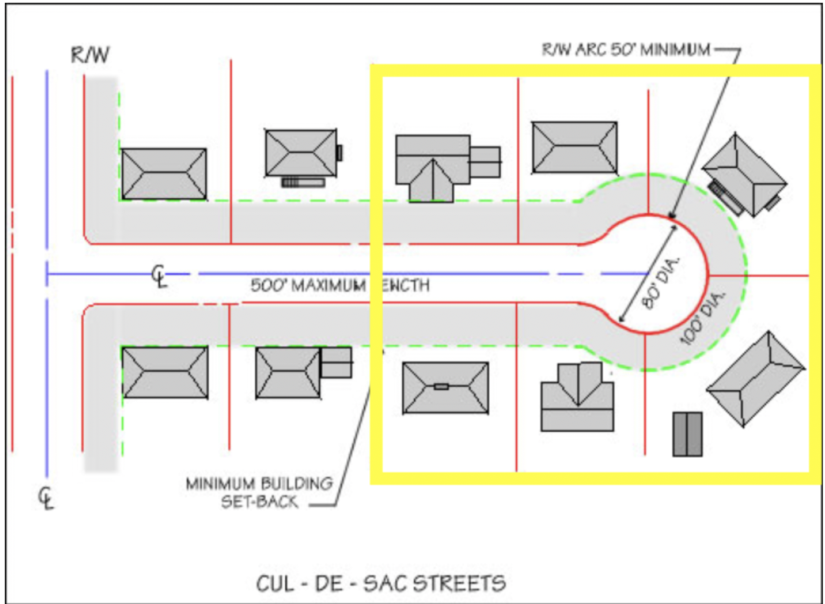

Paint sample or picture of paint color used on another John Wieland/Pulte home in Reunion Country Club. Please provide the home address where the color has been approved; this must be identified.

List ALL areas of the home to be repainted, including the front door. As of
9/20/23 painting of bricks on the exterior of the home is prohibited. (See example below.)

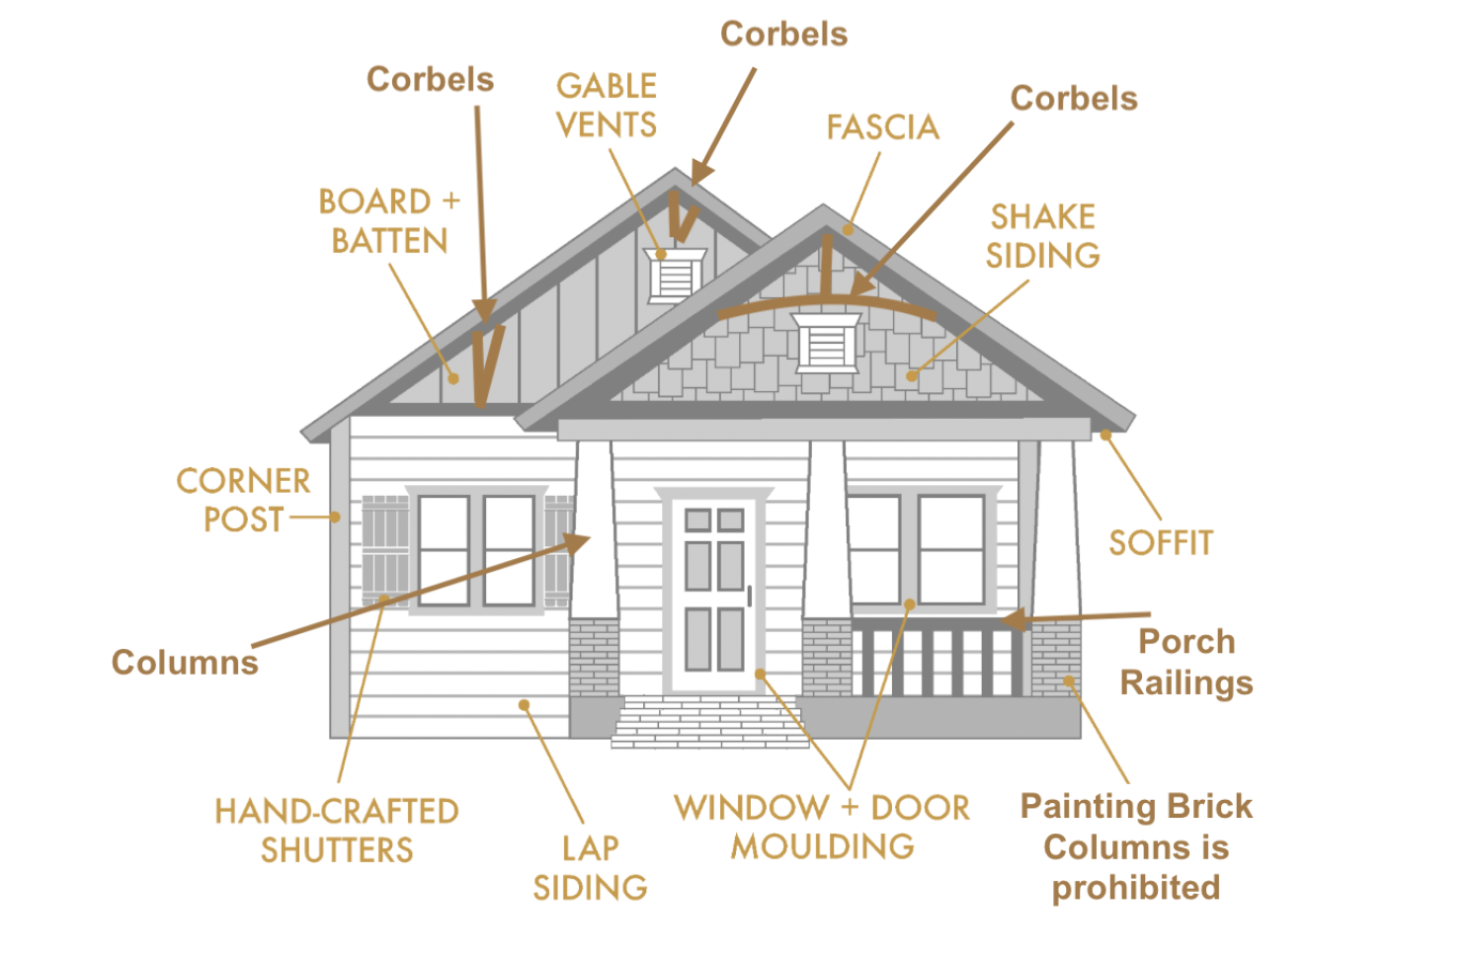
- Corbels - natural stained wood, or painted with approved color
- Cedar Shakes - natural stained wood, or painted or stained to match
- house color
- List garage doors and trim colors
- Garage hardware must be black
- Magnetic decorative carriage-style garage door accent trim hardware is prohibited on metal garage doors

